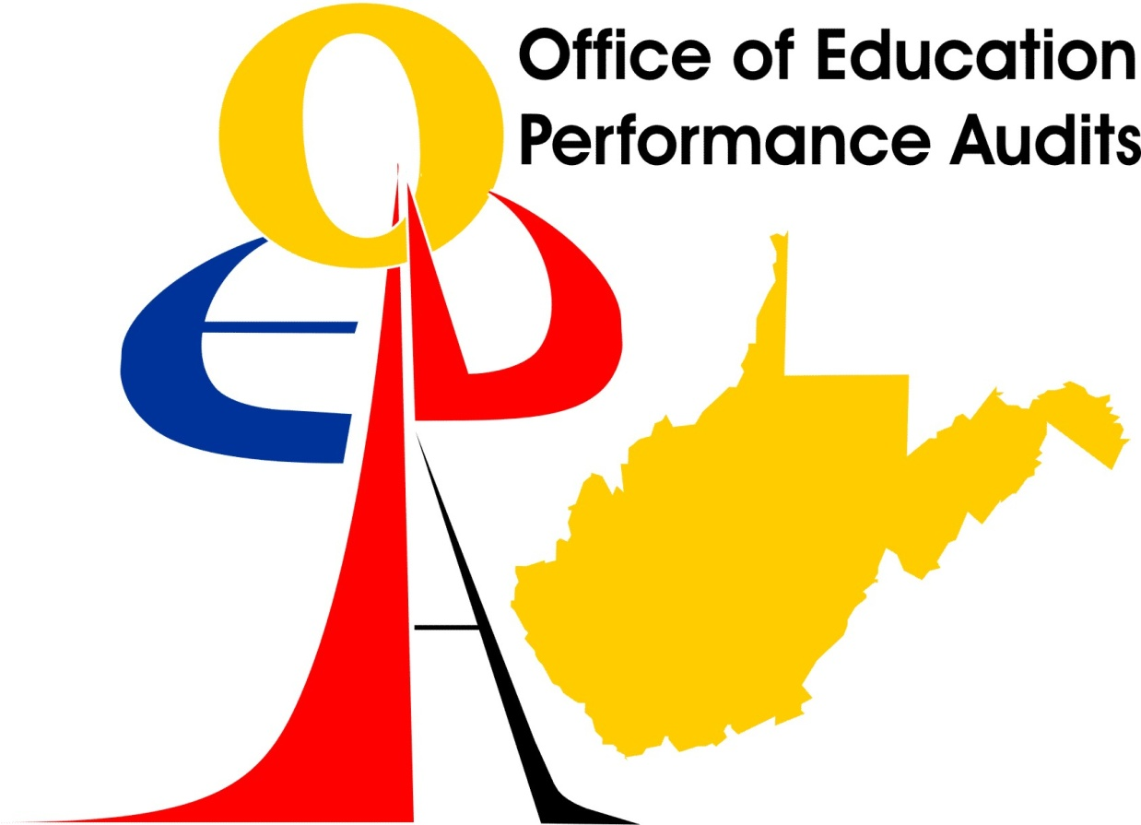

**Final Education Performance Audit Report**

**For**

**RIDGEDALE ELEMENTARY SCHOOL**

**MONONGALIA COUNTY SCHOOL SYSTEM**

**SEPTEMBER 2008**

**West Virginia Board of Education**

INTRODUCTION

An announced Education Performance Audit of Ridgedale Elementary School in Monongalia County was conducted on December 7, 2005.

A Follow-up Education Performance Audit of Ridgedale Elementary School in Monongalia County was conducted May 5, 2008. The purpose of the follow-up was to verify correction of the findings identified during the original Education Performance Audit. The review was in accordance with West Virginia Code §18-2E-5 and West Virginia Board of Education Policy 2320 which specify that a school that meets or exceeds the performance and progress standards but has other deficiencies shall remain on full accreditation status and a county school district shall remain on full approval status for the remainder of the accreditation period and shall have an opportunity to correct those deficiencies. The Code and policy include the provision that a school “. . . does not have any deficiencies which would endanger student health or safety or other extraordinary circumstances as defined by the West Virginia Board of Education.”

**SCHOOL PERFORMANCE**

This section presents the Annual Performance Measures for Accountability and the Education Performance Audit Team’s findings.

**56 MONONGALIA COUNTY**

Frank Devono, Superintendent

**204 RIDGEDALE ELEMENTARY SCHOOL – Needs Improvement**

LeJay Graffious, Principal

Grades K - 05

Enrollment 283 (2004-05 2nd month enrollment report)

**WESTEST 2004-2005**

|  |  |  |  |  |  |  |  |  |
| --- | --- | --- | --- | --- | --- | --- | --- | --- |
| **Group** | **Number Enrolled for FAY** | **Number Enrolled on Test Week** | **Number Tested** | **Participation Rate** | **Percent Proficient** | **Met Part. Rate Standard** | **Met Assessment Standard** | **Met Subgroup Standard** |
| **Mathematics** | | | | | | | | |
| All | 132 | 141 | 141 | 100.00 | 65.15 | Yes | Confidence Interval |  |
| White | 129 | 138 | 138 | 100.00 | 65.89 | Yes | Confidence Interval |  |
| Black | ** | ** | ** | ** | ** | ** | ** | ** |
| Hispanic | * | * | * | * | * | * | * | * |
| Indian | ** | ** | ** | ** | ** | ** | ** | ** |
| Asian | * | * | * | * | * | * | * | * |
| Low SES | 60 | 68 | 68 | 100.00 | 41.66 | Yes | No |  |
| Spec. Ed. | 27 | 31 | 31 | 100.00 | 29.62 | NA | NA | NA |
| LEP | * | * | * | * | * | * | * | * |
| **Reading/Language Arts** | | | | | | | | |
| All | 132 | 141 | 141 | 100.00 | 72.72 | Yes | Yes |  |
| White | 129 | 138 | 138 | 100.00 | 73.64 | Yes | Yes |  |
| Black | ** | ** | ** | ** | ** | ** | ** | ** |
| Hispanic | * | * | * | * | * | * | * | * |
| Indian | ** | ** | ** | ** | ** | ** | ** | ** |
| Asian | * | * | * | * | * | * | * | * |
| Low SES | 60 | 68 | 68 | 100.00 | 56.66 | Yes | Confidence Interval |  |
| Spec. Ed. | 27 | 31 | 31 | 100.00 | 33.33 | NA | NA | NA |
| LEP | * | * | * | * | * | * | * | * |

FAY -- Full Academic Year

* -- 0 students in subgroup

** -- Less than 10 students in subgroup

**Passed**

**Attendance Rate = 100.0%56 MONONGALIA COUNTY**

Frank Devono, Superintendent

**204 RIDGEDALE ELEMENTARY SCHOOL – Passed**

LeJay Graffious, Principal

Grades K - 05

Enrollment 297 (2005-06 2nd month enrollment report)

# WESTEST 2005-2006

|  |  |  |  |  |  |  |  |  |
| --- | --- | --- | --- | --- | --- | --- | --- | --- |
| **Group** | **Number Enrolled for FAY** | **Number Enrolled on Test Week** | **Number Tested** | **Participation Rate** | **Percent Proficient** | **Met Part. Rate Standard** | **Met Assessment Standard** | **Met Subgroup Standard** |
| **Mathematics** | | | | | | | | |
| All | 134 | 144 | 144 | 100.00 | 73.13 | Yes | Yes |  |
| White | 133 | 143 | 143 | 100.00 | 72.93 | Yes | Yes |  |
| Black | ** | ** | ** | ** | ** | ** | ** | ** |
| Hispanic | * | * | * | * | * | * | * | * |
| Indian | * | * | * | * | * | * | * | * |
| Asian | * | * | * | * | * | * | * | * |
| Low SES | 53 | 61 | 61 | 100.00 | 50.94 | Yes | Confidence Interval |  |
| Spec. Ed. | 21 | 26 | 26 | 100.00 | 38.09 | NA | NA | NA |
| LEP | * | * | * | * | * | * | * | * |
| **Reading/Language Arts** | | | | | | | | |
| All | 134 | 144 | 144 | 100.00 | 76.11 | Yes | Yes |  |
| White | 133 | 143 | 143 | 100.00 | 76.69 | Yes | Yes |  |
| Black | ** | ** | ** | ** | ** | ** | ** | ** |
| Hispanic | * | * | * | * | * | * | * | * |
| Indian | * | * | * | * | * | * | * | * |
| Asian | * | * | * | * | * | * | * | * |
| Low SES | 53 | 61 | 61 | 100.00 | 66.03 | Yes | Confidence Interval |  |
| Spec. Ed. | 21 | 26 | 26 | 100.00 | 19.04 | NA | NA | NA |
| LEP | * | * | * | * | * | * | * | * |

FAY -- Full Academic Year

* -- 0 students in subgroup

** -- Less than 10 students in subgroup

**Passed**

**Attendance Rate = 100.0%**

**56 MONONGALIA COUNTY**

Frank Devono, Superintendent

**204 RIDGEDALE ELEMENTARY SCHOOL – Passed**

LeJay Graffious, Principal

Grades K - 05

Enrollment 338 (2006-07 2nd month enrollment report)

# WESTEST 2006-2007

|  |  |  |  |  |  |  |  |  |
| --- | --- | --- | --- | --- | --- | --- | --- | --- |
| **Group** | **Number Enrolled for FAY** | **Number Enrolled on Test Week** | **Number Tested** | **Participation Rate** | **Percent Proficient** | **Met Part. Rate Standard** | **Met Assessment Standard** | **Met Subgroup Standard** |
| **Mathematics** | | | | | | | | |
| All | 123 | 132 | 132 | 100.00 | 63.41 | Yes | Confidence Interval |  |
| White | 121 | 129 | 129 | 100.00 | 64.46 | Yes | Confidence Interval |  |
| Black | ** | ** | ** | ** | ** | ** | ** | ** |
| Hispanic | ** | ** | ** | ** | ** | ** | ** | ** |
| Indian | * | ** | ** | ** | ** | ** | ** | ** |
| Asian | * | * | * | * | * | * | * | * |
| Low SES | 46 | 50 | 50 | 100.00 | 47.82 | Yes | NA |  |
| Spec. Ed. | 22 | 24 | 24 | 100.00 | 31.81 | NA | NA | NA |
| LEP | * | * | * | * | * | * | * | * |
| **Reading/Language Arts** | | | | | | | | |
| All | 123 | 132 | 132 | 100.00 | 65.85 | Yes | Confidence Interval |  |
| White | 121 | 129 | 129 | 100.00 | 66.11 | Yes | Confidence Interval |  |
| Black | ** | ** | ** | ** | ** | ** | ** | ** |
| Hispanic | ** | ** | ** | ** | ** | ** | ** | ** |
| Indian | * | ** | ** | ** | ** | ** | ** | ** |
| Asian | * | * | * | * | * | * | * | * |
| Low SES | 46 | 50 | 50 | 100.00 | 56.52 | Yes | NA |  |
| Spec. Ed. | 22 | 24 | 24 | 100.00 | 27.27 | NA | NA | NA |
| LEP | * | * | * | * | * | * | * | * |

FAY -- Full Academic Year

* -- 0 students in subgroup

** -- Less than 10 students in subgroup

**Passed  
Attendance Rate = 99.9% ANNUAL PERFORMANCE MEASURES FOR ACCOUNTABILITY**

**Below Standard.**

**5.1.1. Achievement.**

Ridgedale Elementary School failed to achieve adequately yearly progress (AYP) in 5.1.1. Achievement in mathematics for the economically disadvantaged students (SES) subgroup. In accordance with Section 9.5 of West Virginia Board of Education Policy 2320, *A Process for Improving Education: Performance Based Accreditation System*, the West Virginia Board of Education issued the school Temporary Accreditation status at the September 2005 State Board meeting.

Ridgedale Elementary School achieved AYP in the economically disadvantaged (SES) subgroup in reading/language arts and the all students (AS) and racial/ethnicity white (W) subgroups in mathematics by application of the confidence interval and may have an achievement deficiency if remediation and interventions have not been emphasized. Additionally, the special education (SE) subgroup was not considered in AYP because of the number (N) less than 50 students. Achievement of students in the SE subgroup in reading/language arts and mathematics was substantially below the State’s proficiency level. Monongalia County curriculum staff and school staff must monitor the achievement of these students and promote instructional strategies and activities that are designed to close the achievement gap.

The Adequate Yearly Progress (AYP) Information by class data showed a high percentage of Grade 3 students performed below mastery (mathematics – 37.50 percent and reading/language arts – 27.50%). This is another consideration for the county and school in school improvement. The following professional development/training opportunities were provided by the West Virginia Department of Education, RESA VII, county and/or school.

1. Curriculum Alignment/Vertical Teaming.
2. Curriculum workshop – music and physical education.
3. Writing workshop.
4. World Book/school issues/alignment.
5. Legacy of Hope/WVDE Module 3.
6. Instructional Framework – Differentiated Instruction.
7. Robert Marzano’s Instructional Strategies that Work.
8. WESTEST analysis and instructional mapping.
9. Inclusion training.
10. Standards based mathematics.

**FOLLOW-UP REVIEW**

**COMPLIANCE. Ridgedale Elementary School achieved adequate yearly progress (AYP) in mathematics for the all students (AS) and racial/ethnicity white (W) subgroups and in reading/language arts for the AS and W subgroups by application of the confidence interval. The economically disadvantaged (SES) and special education (SE) subgroups, with cell sizes fewer than 50, did not score high enough to have made AYP. All subgroups will need continued attention.**

**The school and county continue to offer training and support to the staff that will impact instruction and student achievement. These included:**

**- Academic coach in reading, mathematics, and assessment for two days/week.**

**- Technology coach (part-time) to work with teachers to support technology.**

**- Special education coach (part-time) to train staff in the Response to Intervention (RTI) program and assist teachers with classroom strategies.**

**- Some special education students were included in regular classrooms.**

**- Assessment ETS benchmarking is used with all students three times a year. Test results were used by teachers to redirect instruction to target student needs.**

**- Grade level planning periods were used for collaboration and planning.**

**- Workshop on Differentiated Instruction for all staff.**

**- Faculty book study on *The Art and Science of Teaching* by Robert Marzano.**

**- Faculty book study on *Discipline without Stress, Punishment or Reward*.**

EDUCATION PERFORMANCE AUDIT

HIGH QUALITY STANDARDS

**Necessary to Improve Performance and Progress.**

**6.1. Curriculum**

* + 1. **Curriculum based on content standards and objectives. The curriculum is based on the content standards and objectives approved by the West Virginia Board of Education. (Policy 2510; Policy 2520)**

The staff could not articulate how the Content Standards and Objectives (CSOs) were used to guide the mathematics curriculum. They stated that the new math series was not yet prioritized and that it was not directly correlated to the CSOs. Therefore, the Team determined that the CSOs were not being utilized to drive the mathematics curriculum.

Through teacher interviews, the Team found that special accommodations were not being made to address WESTEST scores of the economically disadvantaged (SES) students. Given the low achievement in this area, it is imperative that the administration and staff address this issue immediately.

**FOLLOW-UP REVIEW**

**COMPLIANCE. The new *Everyday Mathematics* textbook has been aligned with the Content Standards and Objectives (CSOs) and the prioritized curriculum map for mathematics has been revised. The benchmarking program was being used to identify student skill weaknesses and teachers used this information to target classroom instruction. The Response to Intervention (RTI) program was being used to address student skill weaknesses for the economically disadvantaged (SES) subgroup.**

**6.1.3. Learning environment. School staff provides a safe and nurturing environment that is conducive to learning. (Policy 2510)**

The Team observed classrooms and observed that one teacher did not exhibit proper classroom management skills. Students were not actively engaged in the learning process.

**FOLLOW-UP REVIEW**

**COMPLIANCE. The principal took immediate action to provide assistance to the teacher. The academic coach worked with the teacher to assist with effective instructional strategies and classroom management techniques. The classroom was monitored by the principal who provided assistance to the teacher on ways to improve classroom management. The Team visited this classroom and classrooms throughout the building and observed teachers effectively managing the classrooms with varied instruction being provided and students were actively involved in learning.**

**6.2. Student and School Performance**

**6.2.3. Lesson plans and principal feedback. Lesson plans that are based on approved content standards and objectives are prepared in advance and the principal reviews, comments on them a minimum of once each quarter, and provides written feedback to the teacher as necessary to improve instruction. (Policy 2510; Policy 5310)**

Some lesson plans were difficult to follow and would be difficult for a substitute teacher to implement. Plans needed to be enhanced to more clearly indicate what is to be taught.

**FOLLOW-UP REVIEW**

**COMPLIANCE. The principal and staff worked together to improve lesson planning. The Team reviewed several lesson plan books and found them to be complete and useable by a substitute teacher.**

INDICATORS OF EFFICIENCY

Indicators of efficiency for student and school system performance and processes were reviewed in the following areas: Curriculum delivery, including but not limited to, the use of distance learning; facilities; administrative practices; personnel; utilization of regional education service agency, or other regional services that may be established by their assigned regional education service agency. This section contains indicators of efficiency that the Education Performance Audit Team assessed as requiring more efficient and effective application.

The indicators of efficiency listed are intended to guide Ridgedale Elementary School in providing a thorough and efficient system of education. Monongalia County is obligated to follow the Indicators of Efficiency noted by the Team. Indicators of Efficiency shall not be used to affect the approval status of Monongalia County or the accreditation status of the schools.

**7.1.1. Curriculum. The school district and school conduct an annual curriculum audit regarding student curricular requests and overall school curriculum needs, including distance learning in combination with accessible and available** resources.

Given the low achievement rate of the economically disadvantaged students (SES) and special education (SE) subgroups and the marginal performance of other subgroups it is imperative that the staff of Ridgedale Elementary School explore initiatives to increase student achievement.

FOLLOW-UP CONCLUSION

**The county provided three part-time academic coaches to the school to work with the staff and students to find strategies to increase student achievement. Staff development has been provided the staff on effective instructional strategies and differentiated instruction. Book studies have been completed by the staff on effective instructional strategies and classroom management. The county benchmark testing program has been implemented and provides teachers information on individual student achievement three times a year. Teachers use this information to more effectively target their instruction to all students. Some improvement had been made in the achievement scores of the economically disadvantaged (SES) and special education (SE) subgroups, but much remains to be done.**

**BUILDING CAPACITY TO CORRECT DEFICIENCIES**

16.1. Capacity building is a process for targeting resources strategically to improve the teaching and learning process. School and county electronic strategic improvement plan development is intended, in part, to provide mechanisms to target resources strategically to the teaching and learning process to improve student, school, and school system performance.

The Team determined that Ridgedale Elementary School and Monongalia County have the capacity to correct the identified deficiencies.

FOLLOW-UP CONCLUSION

**The deficiencies cited in the education performance audit for Ridgedale Elementary School had been corrected.**

**IDENTIFICATION OF RESOURCE NEEDS**

A thorough and efficient system of schools requires the provision of an adequate level of appropriately managed resources. The West Virginia Board of Education adopted resource evaluation as a part of the accreditation and evaluation process. This process is intended to meaningfully evaluate the needs for facilities, personnel, curriculum, equipment and materials in each of the county’s schools and how those impact program and student performance.

**17.1. Facilities, equipment, and materials.** Facilities and equipment specified in Policy 6200, Chapters 1 through 14, are available in all schools, classrooms, and other required areas. A determination will be made by using the Process for Improving Education (W.Va. Code §18‑2E‑5) whether any identified deficiencies adversely impact and impair the delivery of a high quality educational program if it is below the West Virginia Board of Education standards due to inadequacies or inappropriate management in the areas of facilities, equipment, and materials. The Education Performance Audit Teams shall utilize an assessment instrument for the evaluation of school facilities which generally follows the requirements of Policy 6200. Note: Corrective measures to be taken in response to any identified resource deficiency will of necessity be subject to the feasibility of modifying existing facilities, consideration of alternative methods of instructional delivery, availability of funding, and prioritization of educational needs through Comprehensive Educational Facilities Plans and the West Virginia School Building Authority. This policy does not change the authority, judgment, or priorities of the School Building Authority who is statutorily responsible for prioritizing “Need” for the purpose of funding school improvements or school construction in the State of West Virginia or the prerogative of the Legislature in providing resources. (Policy 6200 *and Tomblin v. Gainer*)

According to the items checked in the School Facilities Evaluation Checklist, the school was below standard in the following areas. The principal checked and the Team confirmed the following school facility resource needs.

**17.1.1. School location.** The site was not 5 acres plus one acre for each 100 students over 240. The site was not large enough for future expansion. Sufficient on-site, solid surface parking was not available for staff, visitors, and individuals with limited physical mobility.

**17.1.10. Specialized instructional areas.** The art facility did not have a ceramic kiln or black-out areas. The music facility did not have adequate space as it shares a space with art and basic skills. Storage was not adequate and the area(s) did not have sufficient numbers of folding chairs, music stands, a podium, or acoustical treatment.

**17.1.14. Food service.** The food service area did not have a chalkboard, bulletin board, a locker/dressing room, lavatory, chairs, or toilet.

**FOLLOW-UP CONCLUSION**

**The facility resource needs remained the same as identified in the Draft Education Performance Audit Report with the exception of the following:**

**17.1.1. School location. The county purchased approximately 2.5 acres of land around the school and expanded the school site.**

EARLY DETECTION AND INTERVENTION

One of the most important elements in the Education Performance Audit process is monitoring student progress through early detection and intervention programs.

Given the achievement levels of students in the economically disadvantaged students (SES) subgroup, Ridgedale Elementary School and Monongalia County must implement curriculum and instruction that will improve students’ achievement. Monongalia County must actively pursue assistance from RESA VII, the West Virginia Department of Education, and the West Virginia Center for Professional Development to assist with school improvement efforts. Curriculum must be data-driven and instruction must be relevant to the curriculum and provide all students the opportunity to learn.

**FOLLOW-UP TEAM SUMMARY**

**The school and county have implemented programs that will improve the curriculum and instruction and lead to improved student achievement. Academic coaches were added to support teachers with effective instructional strategies that can be used in classrooms. Benchmarking tests were in place to provide student achievement information for teachers to use to target student academic needs. Staff development has been provided by the county, RESA VII, West Virginia Department of Education, and the Center for Professional Development in several areas including: RTI training for primary teachers, AIM training for intermediate teachers, Orton Gilliam Diversity Workshop, 21st Century Leadership, and Teachers’ Summer Academy.**

EDUCATION PERFORMANCE AUDIT SUMMARY

The Office of Education Performance Audits recommends that the West Virginia Board of Education continue Ridgedale Elementary School’s previous accreditation status until the 2008 performance data are analyzed and the 2008 Report of Ratings is approved by the West Virginia Board of Education.