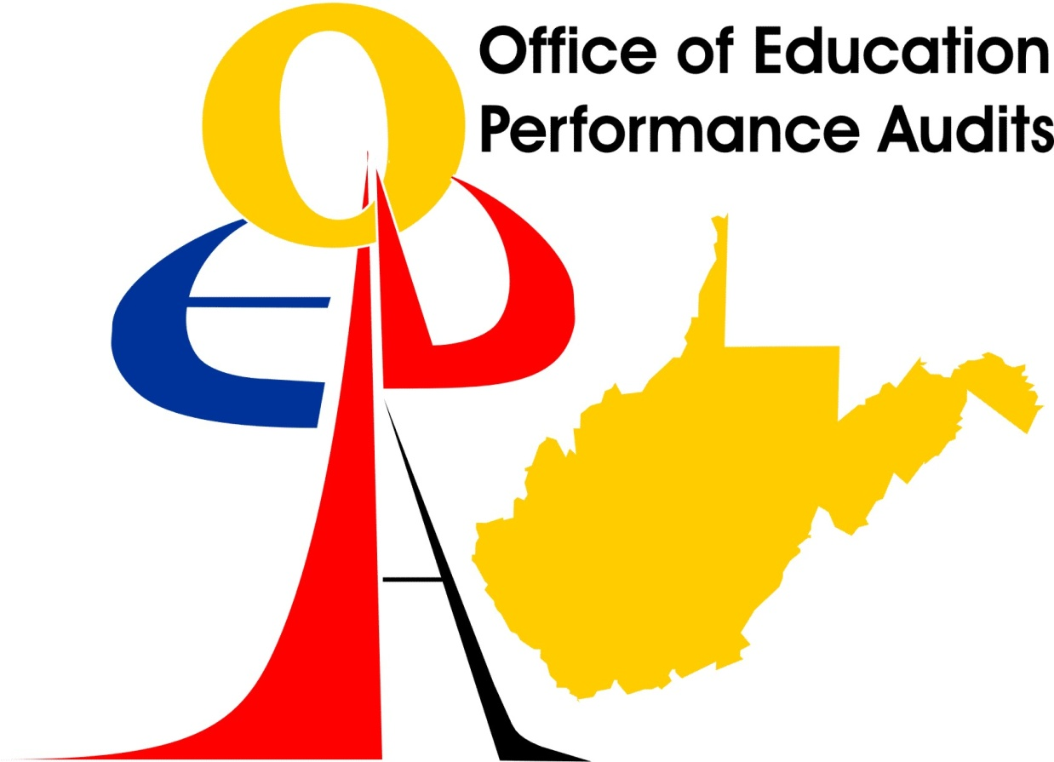

**Final Education Performance Audit Report**

**For**

**WESTWOOD MIDDLE SCHOOL**

**MONONGALIA COUNTY SCHOOL SYSTEM**

**september 2008**

**West Virginia Board of Education**

INTRODUCTION

An announced Education Performance Audit of Westwood Middle School in Monongalia County was conducted on December 13, 2006.

A Follow-up Education Performance Audit of Westwood Middle School in Monongalia County was conducted May 8, 2008. The purpose of the follow-up was to verify correction of the findings identified during the original Education Performance Audit. The review was in accordance with West Virginia Code §18-2E-5 and West Virginia Board of Education Policy 2320 which specify that a school that meets or exceeds the performance and progress standards but has other deficiencies shall remain on full accreditation status and a county school district shall remain on full approval status for the remainder of the accreditation period and shall have an opportunity to correct those deficiencies. The Code and policy include the provision that a school “. . . does not have any deficiencies which would endanger student health or safety or other extraordinary circumstances as defined by the West Virginia Board of Education.”

**SCHOOL PERFORMANCE**

This section presents the Annual Performance Measures for Accountability and the Education Performance Audit Team’s findings.

**56 MONONGALIA COUNTY**

Frank Devono, Superintendent

**302 WESTWOOD MIDDLE SCHOOL – Needs Improvement**

Leonard Haney, Principal

Grades 06 - 08

Enrollment 477 (2005-06 2nd month enrollment report)

**WESTEST 2005-2006**

|  |  |  |  |  |  |  |  |  |
| --- | --- | --- | --- | --- | --- | --- | --- | --- |
| **Group** | **Number Enrolled for FAY** | **Number Enrolled on Test Week** | **Number Tested** | **Participation Rate** | **Percent Proficient** | **Met Part. Rate Standard** | **Met Assessment Standard** | **Met Subgroup Standard** |
| **Mathematics** | | | | | | | | |
| All | 445 | 469 | 459 | 97.86 | 65.51 | Yes | Yes |  |
| White | 416 | 438 | 428 | 97.71 | 66.00 | Yes | Yes |  |
| Black | 24 | 26 | 26 | 100.00 | 50.00 | NA | NA | NA |
| Hispanic | * | * | * | * | * | * | * | * |
| Indian | ** | ** | ** | ** | ** | ** | ** | ** |
| Asian | ** | ** | ** | ** | ** | ** | ** | ** |
| Low SES | 255 | 274 | 266 | 97.08 | 55.06 | Yes | Averaging |  |
| Spec. Ed. | 111 | 119 | 114 | 95.79 | 31.13 | Yes | No |  |
| LEP | ** | ** | ** | ** | ** | NA | NA | NA |
| **Reading/Language Arts** | | | | | | | | |
| All | 445 | 469 | 458 | 97.65 | 72.35 | Yes | Averaging |  |
| White | 416 | 438 | 427 | 97.48 | 72.83 | Yes | Averaging |  |
| Black | 24 | 26 | 26 | 100.00 | 62.50 | NA | NA | NA |
| Hispanic | * | * | * | * | * | * | * | * |
| Indian | ** | ** | ** | ** | ** | ** | ** | ** |
| Asian | ** | ** | ** | ** | ** | ** | ** | ** |
| Low SES | 255 | 274 | 264 | 96.35 | 62.04 | Yes | Confidence Interval - Averaging |  |
| Spec. Ed. | 111 | 119 | 111 | 93.27 | 31.06 | By Average | No |  |
| LEP | ** | ** | ** | ** | ** | NA | NA | NA |

FAY -- Full Academic Year

* -- 0 students in subgroup

** -- Less than 10 students in subgroup

**Passed**

**Attendance Rate = 95.8%**

**56 MONONGALIA COUNTY**

Frank Devono, Superintendent

**302 WESTWOOD MIDDLE SCHOOL – Needs Improvement**

Leonard Haney, Principal

Grades 06 - 08

Enrollment 451 (2006-07 2nd month enrollment report)

**WESTEST 2006-2007**

|  |  |  |  |  |  |  |  |  |
| --- | --- | --- | --- | --- | --- | --- | --- | --- |
| **Group** | **Number Enrolled for FAY** | **Number Enrolled on Test Week** | **Number Tested** | **Participation Rate** | **Percent Proficient** | **Met Part. Rate Standard** | **Met Assessment Standard** | **Met Subgroup Standard** |
| **Mathematics** | | | | | | | | |
| All | 436 | 458 | 451 | 98.47 | 74.24 | Yes | Yes |  |
| White | 408 | 428 | 421 | 98.36 | 74.93 | Yes | Yes |  |
| Black | 27 | 27 | 27 | 100.00 | 62.96 | NA | NA | NA |
| Hispanic | * | * | * | * | * | * | * | * |
| Indian | * | * | * | * | * | * | * | * |
| Asian | ** | ** | ** | ** | ** | ** | ** | ** |
| Low SES | 247 | 261 | 256 | 98.08 | 66.66 | Yes | Confidence Interval |  |
| Spec. Ed. | 91 | 100 | 98 | 98.00 | 37.07 | Yes | No |  |
| LEP | * | * | * | * | * | * | * | * |
| **Reading/Language Arts** | | | | | | | | |
| All | 436 | 458 | 453 | 98.90 | 75.75 | Yes | Confidence Interval |  |
| White | 408 | 428 | 423 | 98.83 | 75.06 | Yes | Confidence Interval |  |
| Black | 27 | 27 | 27 | 100.00 | 85.18 | NA | NA | NA |
| Hispanic | * | * | * | * | * | * | * | * |
| Indian | * | * | * | * | * | * | * | * |
| Asian | ** | ** | ** | ** | ** | ** | ** | ** |
| Low SES | 247 | 261 | 258 | 98.85 | 66.93 | Yes | Safe Harbors |  |
| Spec. Ed. | 91 | 100 | 99 | 99.00 | 35.55 | Yes | No |  |
| LEP | * | * | * | * | * | * | * | * |

FAY -- Full Academic Year

* -- 0 students in subgroup

** -- Less than 10 students in subgroup

**Passed  
Attendance Rate = 95.5%**

**ANNUAL PERFORMANCE MEASURES FOR ACCOUNTABILITY**

**Below Standard.**

**5.1.1. Achievement.**

Westwood Middle School failed to achieve adequately yearly progress (AYP) in 5.1.1. Achievement for the special education (SE) subgroup. In accordance with Section 9.4 of West Virginia Board of Education Policy 2320, *A Process for Improving Education: Performance Based Accreditation System*, the West Virginia Board of Education continued the school’s Conditional Accreditation status at the October 2006 State Board meeting.

Westwood Middle School achieved AYP in the economically disadvantaged (SES) subgroup in mathematics by averaging and in reading/language arts by application of the confidence interval and averaging. It is further noted that the racial/ethnicity black (B) subgroup with the number (N) less than 50, scored below the State’s percent proficient level in mathematics and reading/language arts. The county curriculum staff and school staff are urged to address these subgroups in the county and school Five-Year Strategic Plans and apply interventions to close the achievement gap for the B and SES students.

Student achievement on the 2005-2006 West Virginia Writing Assessment indicated that 59 percent of the Grade 7 students scored at or above mastery compared to 77 percent for Monongalia County and 75 percent for the State. The school is urged to ensure that a schoolwide writing rubric is incorporated by all teachers.

The following professional development and/or training opportunities were provided by the county and/or school.

1. General Educators Working with Special Education Students. - (county).
2. Six Trait Writing Strategies. - (county).
3. Interactive Whiteboard. - (county).
4. Wilson Language Systems - (county).
5. Various concepts of “Meeting Our Greatest Challenges Head-On”. - (school).

**FOLLOW-UP REVIEW**

**MET STANDARD. West Virginia Board of Education Policy 2320, *A Process for Improving Education*-*Performance Based Accreditation System* in Section §126-13-6 provides:**

**6.1. A system of points on an index will be used to assess and weigh annual performance measures for state accreditation of schools and approval of school systems that gives credit or points on an index to prevent any one measure alone from causing a school to achieve less than full accreditation status or a school system from achieving less than full approval status: Provided, That a school or school system that achieves AYP is eligible for no less than full accreditation or full approval status, as applicable, and the system established pursuant to this subsection shall only apply to schools and school systems that do not achieve AYP.**

**The index showed that Westwood Middle School performed within the point range (841-724) for full accreditation status.**

**Even though the percent of special education students scoring at percent proficient on the 2007 WESTEST increased from 31.13 percent to 37.07 percent in mathematics and from 31.06 percent to 35.55 percent in reading/language arts, Westwood Middle School failed to achieve adequate yearly progress (AYP) in the special education (SE) subgroup.**

**The Team noted that the percent proficient increased for all subgroups, most notably in mathematics. The school has demonstrated significant improvement in student achievement and was following a course of action that should lead to further improvement.**

EDUCATION PERFORMANCE AUDIT

HIGH QUALITY STANDARDS

**6.1. Curriculum**

**6.1.5. Instructional strategies. Staff demonstrates the use of the various instructional strategies and techniques contained in Policies 2510 and 2520. (Policy 2510; Policy 2520)**

The Team observed a lack of hands-on, active, and engaging activities in the self-contained special education classrooms. Research and best practices have shown hands on, active and engaging activities to be educationally appropriate and effective strategies for students, particularly for students receiving services for moderate mental disability. The Team further noted a need to address a variety of learning modalities such as kinesthetic or visual learning, a need for using manipulatives and active student learning, and a need to diminish the use of worksheets.

**FOLLOW-UP REVIEW**

**COMPLIANCE. Staff development continued to be provided to the special education staff. Staff development sessions included: Differentiated Instruction, training for co-teachers, Project Teach, and data analysis and choosing effective Differentiated Instruction methods. Funds were provided for special education hands-on learning activities. A schoolwide initiative was implemented that moved the special education students from self-contained classrooms to the general education classrooms for instruction in the core subjects and related arts. Special education teachers were serving as co-teachers in the general education classrooms.**

**6.1.8. Instructional materials. Sufficient numbers of approved up‑to‑date textbooks, instructional materials, and other resources are available to deliver curricular content for the full instructional term. (Policy 2510)**

Through faculty and student interviews the Team found that some teachers posted materials lists for students to purchase. This is inconsistent with a free and appropriate public education. Monongalia County is urged to check practices at all schools within the county to assure that students are not required to purchase required materials that should be provided by the county and/or school.

**FOLLOW-UP REVIEW**

**COMPLIANCE. All teachers were advised that they were not to require students or their parents to provide supplies for instruction. The principal also sent a letter to parents informing them of this policy.**

**6.6. Personnel**

**6.6.2. Licensure.** Two teachers’ names did not appear on the school’s master schedule submitted to the West Virginia Department of Education. One teacher in the school did not hold the appropriate certification for the position.

**FOLLOW-UP REVIEW**

**COMPLIANCE. The school was unable to identify who the two teachers were whose names did not appear on the school’s master schedule. It was assumed there was an error in the list. The teacher who did not hold the appropriate certification for the position held had been replaced with a teacher appropriately certified.**

**RECOMMENDATIONS**

**6.1.6. Instruction in writing.** Faculty interviews indicated that writing strategies were not being implemented consistently across all instructional areas. While writing was a priority, several different writing programs were being implemented simultaneously. The Team recommended that a consistent schoolwide writing strategy be used across all disciplines including special education and consultative educators.

**FOLLOW-UP REVIEW**

**RECOMMENDATION FOLLOWED. The school faculty adopted the Four Square Writing Program for Grade 6 and the My Access Writing Program for Grades 7 and 8.**

**6.2.3. Lesson plans and principal feedback.** A consistent format for developing lesson plans was not being used and some teachers continued to use the Monongalia County form dated 1999 which included West Virginia Board of Education Instructional Goals and Objectives (IGOs). The Team recommended that faculty members use a uniform lesson plan template with the omission of the IGOs.

**FOLLOW-UP REVIEW**

**RECOMMENDATION FOLLOWED. The faculty developed and committed to using a standard lesson plan format that will contain the Content Standards and Objectives (CSOs) being taught.**

INDICATORS OF EFFICIENCY

Indicators of efficiency for student and school system performance and processes were reviewed in the following areas: Curriculum delivery, including but not limited to, the use of distance learning; facilities; administrative practices; personnel; utilization of regional education service agency, or other regional services that may be established by their assigned regional education service agency. This section contains indicators of efficiency that the Education Performance Audit Team assessed as requiring more efficient and effective application.

The indicators of efficiency listed are intended to guide Westwood Middle School in providing a thorough and efficient system of education. Monongalia County is obligated to follow the Indicators of Efficiency noted by the Team. Indicators of Efficiency shall not be used to affect the approval status of Monongalia County or the accreditation status of the schools.

**7.1.1. Curriculum. The school district and school conduct an annual curriculum audit regarding student curricular requests and overall school curriculum needs, including distance learning in combination with accessible and available resources.**

It is imperative that all special education teachers vary the instruction regularly to maintain student interest in the lessons. All learning modalities must be incorporated in every lesson and manipulatives and active student learning must be incorporated in instruction. Worksheets, while useful in some settings, must not be overused.

FOLLOW-UP CONCLUSION

**Special education teachers received extensive professional development on effective strategies for teaching special education students and were allocated funds for purchasing manipulatives. The special education program was reorganized and most special education students received instruction in the general education classrooms with support from the special education teachers participating as co-teachers.**

**BUILDING CAPACITY TO CORRECT DEFICIENCIES**

16.1. Capacity building is a process for targeting resources strategically to improve the teaching and learning process. School and county electronic strategic improvement plan development is intended, in part, to provide mechanisms to target resources strategically to the teaching and learning process to improve student, school, and school system performance.

The Team determined that Westwood Middle School and Monongalia County have the capacity to correct the identified deficiencies. However, the capacity must be developed in the special education department to provide quality services as demonstrated by the general education teachers. The Team recommended that the Monongalia County School System Director of Special Education and the school administrator engage the Special Education Director and the Professional Development Director at RESA VII in developing the school’s capacity to improve the school’s achievement of the special education students.

FOLLOW-UP CONCLUSION

**The Monongalia County Central Office staff supported Westwood Middle School in correcting the identified deficiencies. The special education program was reorganized and all special education students were included in the general education classrooms to improve the quality of instruction they receive. The special education teachers served as co-teachers in the classrooms to provide support for the special education students (and other students) in the classrooms.**

**EARLY DETECTION AND INTERVENTION**

One of the most important elements in the Education Performance Audit process is monitoring student progress through early detection and intervention programs.

Given the achievement levels of students in the special education (SE) subgroup, Westwood Middle School and Monongalia County must implement high yield instructional practices and 21st Century learning skills that will improve achievement. Additional staff development related to instructional strategies of special education students is highly advised. Monongalia County must actively pursue assistance from RESA VII, the West Virginia Department of Education, and the West Virginia Center for Professional Development to assist with school improvement efforts. Curriculum must be data-driven and instruction must be relevant to the curriculum and provide all students the opportunity to learn.

The percent proficient in all subgroups declined significantly in all subgroups from the 2005 assessment to 2006. The school and county are aware of this decline and have been diligently concentrating on improving student achievement. The special education self-contained classes remained an issue during the Education Performance Audit.

**FOLLOW-UP TEAM SUMMARY**

**Professional development for teachers continued with the support of Monongalia County Central Office staff, RESA VII, West Virginia Department of Education, and the West Virginia Center for Professional Development. Training sessions provided included: Differentiated Instruction by presenter Ann Benninghof, co-teaching training by presenter Marsha Bailes, Project Teach by presenter Ann Benninghof, and Data Analysis and Use by presenter Lisa Hines.**

**Planned future professional development opportunities in which some Westwood Middle School personnel will participate included:**

* **21st Century Model Schools Conference - June 2008**
* **21st Century Teacher Leadership Institute - Summer 2008**
* **Process for Addressing Disabilities – Orton Gillingham – August 2008**

**To address the achievement of special education students, the special education class schedule has been reorganized to allow special education students to be included in the regular classrooms with support from the special education teachers in a co-teacher role.**

**EDUCATION PERFORMANCE AUDIT SUMMARY**

The Office of Education Performance Audits recommends that the West Virginia Board of Education continue Westwood Middle School’s previous accreditation status until the 2008 performance data are analyzed and the 2008 Report of Ratings is approved by the West Virginia Board of Education.